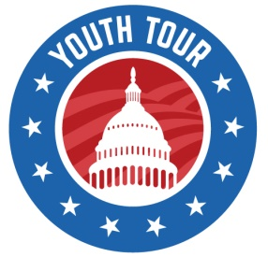
2021 Youth Tour

Student Expectations for COVID-19 Restrictions

There is no guarantee from the National Rural Electric Cooperative Association (NRECA) to hold the Youth Tour in 2021. Please be aware that regardless of the actions by your co-op, the trip may still be canceled.
Your co-op, Montana Electric Cooperatives’ Association (MECA), and NRECA cannot guarantee you will not contract COVID-19 during the trip, regardless of our commitment to adhere to guidelines from the Center for Disease Control and Prevention and suggestions from NRECA.
Youth Tour is completely voluntary – please keep the following list in mind before applying:
- You will be REQUIRED to wear a mask during times we are in public or common areas and traveling. Your mask needs to remain on your face until you get approval to remove it from a Youth Tour chaperone. If you cannot wear a mask for medical reasons, you will be asked to provide a note and bring it with you. If you don’t want to wear a mask for personal reasons, please do not apply. If you cannot wear a mask for a nonmedical reason that you believe would make you exempt from a mask mandate in Washington, D.C., please contact your cooperative prior to applying.
- You will be REQUIRED to sanitize common areas in the hotel rooms (including bathrooms and counters), sanitize your phone, room key, and other belongings DAILY. The hotel will not clean the hotel rooms after we check in. Sanitizing supplies will be provided.
- You will be REQUIRED to use hand-sanitizing stations while in D.C., and wash your hands immediately upon returning to your hotel room.
- You will be REQUIRED to report ANY symptoms of COVID-19 to a chaperone immediately.
- You will be REQUIRED to have a daily health screening (complete with temperature check) with a chaperone before starting our activities each day.
- You may be asked to provide a doctor’s note proving you have tested negative for COVID-19 before leaving for the trip.
- During the trip, you will have contact with students from other states. There will be open communication between the states’ Youth Tour Directors, and if a positive case is identified in another state we had contact with, you will need to be tested for COVID-19 and may be asked to quarantine in D.C. or upon returning home.
- We encourage parents to have their student tested after returning from the trip and to quarantine for 14 days if they test positive.

